Architecture Decision Request
Business Unit: | Infrastructure and Operations | Requested by: | Azure Cloud Foundation
Initiative name: | Azure Storage Mover Connectivity | Date submitted: | 08 Jun 2026
Request number: | <TBD> | Target decision date: | 06 July 2026

PART 1: DECISION CONTEXT
Decision name: | Azure Storage Mover Connectivity
Decision description: | Azure Storage Mover is a required service for the ARM and Isilon migration programs. There is a requirement for Azure Storage Mover to connect to US East for its management plane.
Decision background: | Azure Storage Mover requires connectivity to the management plane which is currently hosted in US East(2) regions. As a result, our current Private DNS Zones for domains *.guestconfiguration.azure.com and *.his.arc.azure.com.  Note: The management plane only receives metadata and all data is transferred directly from Client through Storage Mover Agent VM, residing in WDC, to the destination storage solution in our Canada Life Tenant, privately via the ExpressRoute.  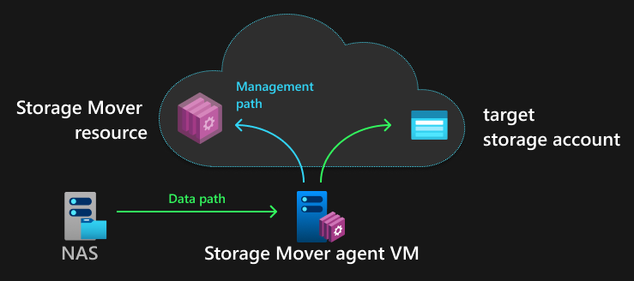
Options Considered: | In this decision request, we consider two options  - Move existing Private Endpoints to US East for ARC domains *.guestconfiguration.azure.com and  *.his.arc.azure.com.  - Implement Azure Arc Gateway. (The next generation for ARC dependent services.)
Options not considered:
Enterprise Context
Divisional Context

Decision Roles using RAPID ® Model
RECOMMEND (R) | AGREE (A) | PERFORM (P) | INPUT (I) | DECIDE (D)
Dan Caruso | Dan Caruso  Chris Farrell  Jason Pruden  Don Davidson  Santhosh Chandrashekar | Cloud Foundation Squad | Sona Mesgar-Zadeh | Gord Rempel

PART 2: DECISION ANALYSIS
öINSTRUCTIONS: | List options for further analysis weighted against decision criteria and project/program delivery impact.
Option 1 | Private DNS Zone in US East Region  To ensure Storage Mover can connect to backend ARC services we would relocate the existing private DNS zones for *.guestconfiguration.azure.com and *.his.arc.azure.com will be recreated in US East and connected to existing Private Endpoints in Canada Central.  Pros:  - Traffic is kept inside ExpressRoute to reach services required for Storage Movers management plane  Cons:  - Arc Agents (~30) will need to be reinstalled and will now be going to US East.  - US east region will be used for all services that require *.guestconfiguration.azure.com and *.his.arc.azure.com services.  - Anti pattern
Option 2 | Azure Arc Gateway  Azure Arc Gateway simplifies multi-region hybrid management by centralizing on-premises traffic through the Azure Front Door global edge network. Allowing Arc dependent services with regional dependencies to work across the environment.  Arc Gateway will require the following URLs to be allowlisted via Canada Life’s proxy.  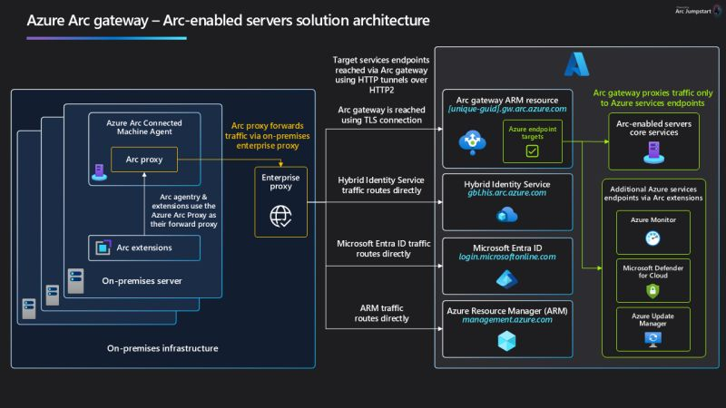  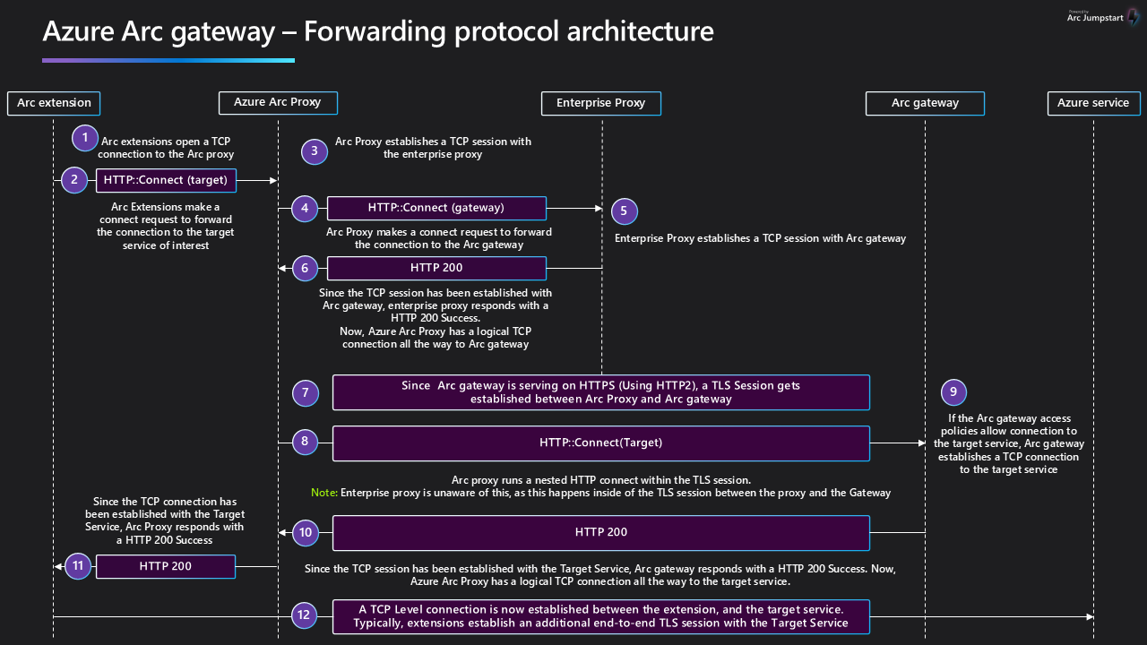  Pros:  - Multi Region support, allows Arc Agents to connect to Canada Central region and Storage Mover to connect to US East.  - Future Proof, Arc Gateway is the direction Azure is going, ensures we can handle new services that have Arc dependencies.  Cons:  - Arc Gateway does not offer a private endpoint; traffic will securely traverse the internet to Azure Front door.  - Arc Agents need to be reinstalled (~30 Agents)
  URL | Purpose
  [Your URL Prefix].gw.arc.azure.com | Your gateway URL (This URL can be obtained by running az connectedmachine gateway list after you create your gateway Resource)
  management.azure.com | Azure Resource Manager Endpoint, required for Azure Resource Manager control channel
  login.microsoftonline.com | Microsoft Entra ID’s endpoint, for acquiring Identity access tokens
  gbl.his.arc.azure.com | The cloud service endpoint for communicating with Azure Arc agents
  <region>.his.arc.azure.com | Used for Arc’s core control channel
  packages.microsoft.com | Required to acquire Linux based Arc agentry payload, only needed to connect Linux servers to Arc
  download.microsoft.com | Used to download the Windows installation package

I
SUPPLEMENTAL INFORMATION:
Comparative Analysis

Criteria | Option 1  Private DNS Zone in US East Region | Option 2  Azure Arc Gateway
Architectural Principles and Standards Integrity | Meets | Meets
Security, Risk, Compliance | Meets | Minimal Change
Cost | Meets | Meets
Engineering Factors
Maintainability | Minimal Change | Improved
Performance | No Change | Meets
Reliability | No Change | Improved
Scalability | No Change | Improved
Manageability | No Change | Improved

Key Differentiating Factors:
- Key factor here is traffic that has historically used private endpoints would be moved to internet egress. However this is not unprecedented as EntraID operates in this fashion and handles far more sensitive data.
öPART 2 IS COMPLETE WHEN
Options analysis is complete and the decision is ready for review
I

PART 3: RECOMMENDATION & APPROVAL
öINSTRUCTIONS: | List recommendation after review(s) are complete with impacted stakeholders
Recommendation: | Option 2: Azure Arc Gateway
Final decision:

AGREES:
Santhosh Chandrashekar
Jason Pruden
Chris Farrell
Dan Caruso
APPROVAL:
Gord Rempel
öPART 3 IS COMPLETE WHEN
The decision is made

PART 4: POST-DECISION ACTIONS REQUIRED
öINSTRUCTIONS: |  | Complete the following actions to formalize and communicate the decision
 | Update decision document and program decision log to reflect decision made and mark the decision closed.
 | Send affected stakeholders an e-mail summarizing the decision outcome

